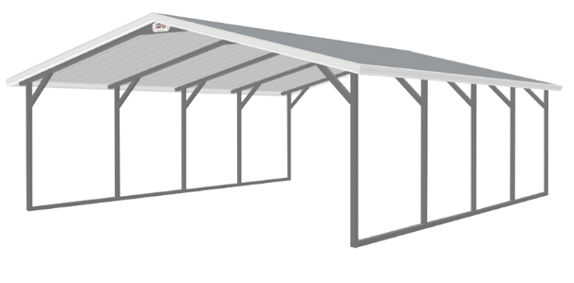
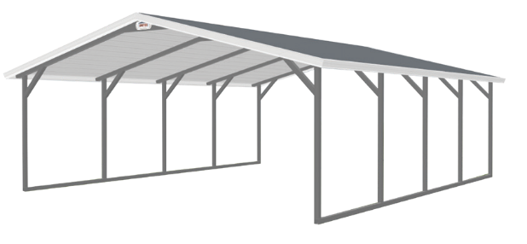
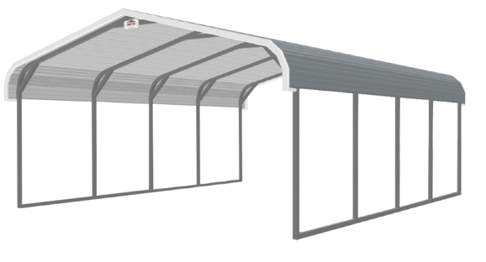
gmai
LOCAL DEALER PHONE 55NUMBER:
STATE: IL
READY TO DESIGN YOUR METAL BUILDING?
GIVE US A CALL AT 563-503-9726 OR VISIT AT 18790 Elston Road Fulton, IL 61252
CUSTOM SIZES AVAILABLE
ENGINEERED CERTIFIED
ARRAY OF AVAILABLE COLORS
Sheet Metal Longer Than 31 Ft Will Result in Overlapping, Recommend Vertical Roofing To Avoid Possible Leaks.
HAWAIIAN BLUE
BRIGHT WHITE
BL ACK
ZINC GREY
PEWTER GREY
TAUPE
BROWN
MOCHA TAN
PEBBLE BEIGE
FOREST GREEN
BURGUNDY
BARN RED
LIGHT STONE
STANDARD 14 - GAUGE 2 1 / 2” STEEL (6 FT STANDARD LEGS)
STANDARD 12- GAUGE 2 1 /4” STEEL (6 FT STANDARD LEGS)
18’ x 21’ x 6’ (14 - GA)
18’ x 21’ x 6’ (14 - GA)
18’ x 21’ x 6’ (14 - GA)
A-FRAME HORIZONTAL
A-FRAME VERTICAL

REGULAR

12 x 21 | $1,870 | 12 x 26 | $2,340 | 12 x 31 | $2,810 | 12 x 36 | $3,275 | 12 x 41 | $3,745 | 12 x 46 | $4,210 | 12 x 51 | $4,680
18 x 21 | $2,160 | 18 x 26 | $2,700 | 18 x 31 | $3,240 | 18 x 36 | $3,780 | 18 x 41 | $4,320 | 18 x 46 | $4,860 | 18 x 51 | $5,400
20 x 21 | $2,560 | 20 x 26 | $3,200 | 20 x 31 | $3,840 | 20 x 36 | $4,480 | 20 x 41 | $5,120 | 20 x 46 | $5,760 | 20 x 51 | $6,400
22 x 21 | $2,950 | 22 x 26 | $3,685 | 22 x 31 | $4,420 | 22 x 36 | $5,160 | 22 x 41 | $5,895 | 22 x 46 | $6,630 | 22 x 51 | $7,370
24 x 21 | $3,310 | 24 x 26 | $4,140 | 24 x 31 | $4,970 | 24 x 36 | $5,795 | 24 x 41 | $6,625 | 24 x 46 | $7,450 | 24 x 51 | $8,280
26 x 21 | $4,370 | 26 x 26 | $5,460 | 26 x 31 | $6,550 | 26 x 36 | $7,645 | 26 x 41 | $8,735 | 26 x 46 | $9,830 | 26 x 51 | $10,920
28 x 21 | $4,705 | 28 x 26 | $5,880 | 28 x 31 | $7,055 | 28 x 36 | $8,230 | 28 x 41 | $9,410 | 28 x 46 | $10,585 | 28 x 51 | $11,760
30 x 21 | $5,040 | 30 x 26 | $6,300 | 30 x 31 | $7,560 | 30 x 36 | $8,820 | 30 x 41 | $10,080 | 30 x 46 | $11,390 | 30 x 51 | $12,600

12 x 21 | $2,280 | 12 x 26 | $2,850 | 12 x 31 | $3,420 | 12 x 36 | $3,990 | 12 x 41 | $4,560 | 12 x 46 | $5,130 | 12 x 51 | $5,700
18 x 21 | $2,880 | 18 x 26 | $3,600 | 18 x 31 | $4,320 | 18 x 36 | $5,040 | 18 x 41 | $5,760 | 18 x 46 | $6,480 | 18 x 51 | $7,200
20 x 21 | $3,200 | 20 x 26 | $4,000 | 20 x 31 | $4,800 | 20 x 36 | $5,600 | 20 x 41 | $6,400 | 20 x 46 | $7,200 | 20 x 51 | $8,000
22 x 21 | $3,740 | 22 x 26 | $4,675 | 22 x 31 | $5,610 | 22 x 36 | $6,545 | 22 x 41 | $7,480 | 22 x 46 | $8,415 | 22 x 51 | $9,350
24 x 21 | $4,080 | 24 x 26 | $5,100 | 24 x 31 | $6,120 | 24 x 36 | $7,140 | 24 x 41 | $8,160 | 24 x 46 | $9,180 | 24 x 51 | $10,200
26 x 21 | $4,940 | 26 x 26 | $6,175 | 26 x 31 | $7,410 | 26 x 36 | $8,645 | 26 x 41 | $9,880 | 26 x 46 | $11,115 | 26 x 51 | $12,350
28 x 21 | $5,320 | 28 x 26 | $6,650 | 28 x 31 | $7,980 | 28 x 36 | $9,310 | 28 x 41 | $10,640 | 28 x 46 | $11,970 | 28 x 51 | $13,300
30 x 21 | $5,700 | 30 x 26 | $7,125 | 30 x 31 | $8,550 | 30 x 36 | $9,975 | 30 x 41 | $11,400 | 30 x 46 | $12,825 | 30 x 51 | $14,250

- Prices are subject to change without notice. Colors listed above are examples only, please ask a Clinton Custom Sheds representative for an actual color sample. 12-gauge steel option carries a 20-year limited warranty covers the rust throughout the framing assuming normal care and maintenance. The 14-gauge steel option carries a 1-year no rust warranty. 22 ft wide and up, recommended use of the 12-gauge material. All buildings have a snow load of 40 PSF (pounds per square foot). No warranty is provided for leaking at the base rail. All buildings are installed with the standard steel rebar rod which does not provide any warranty against wind damage. To obtain the wind warranty, you must purchase all required amount of anchors. All orders are C.O.D. (Prices Effective 03/2022)

OPTIONS & ACCESSORIES

- Prices are subject to change without notice. $150 dollar return fee will be added to additions less than $1,000 dollars. (WAINS is short for wainscotings)

A- FR AME HORIZONTAL: ( ADDITIONAL COST)
A-FRAME ROOFING OPTIONS:
W

WALK- IN DOOR:
H 32” x 72” $300
36” x 80” $350

W

WINDOWS:
H (White Frame)
24” x 36” $225
30” x 36” $250

W

H

ROLL UP GAR AGE DOOR:
WIDTH  12’—30’ | 21’ L |  | 26’ L |  | 31’ L |  | 36’ L |  | 41’ L |  | 46’ L |  | 51’ L
 | + $200 |  | + $225 |  | + $250 |  | + $275 |  | + $300 |  | + $325 |  | + $350
A- FR AME VERTICAL: ( ADDITIONAL COST)
12’  18’  20’  22’  24’  26’  28’  30’ | + $625 |  | + $700 |  | + $800 |  | + $1,050 |  | + $1,250 |  | + $1,325 |  | + $1,400
 | + $675 |  | + $750 |  | + $850 |  | + $1,150 |  | + $1,350 |  | + $1,425 |  | + $1,500
 | + $700 |  | + $775 |  | + $900 |  | + $1,200 |  | + $1,400 |  | + $1,475 |  | + $1,550
 | + $725 |  | + $850 |  | + $950 |  | + $1,250 |  | + $1,450 |  | + $1,575 |  | + $1,700
 | + $750 |  | + $875 |  | + $975 |  | + $1,300 |  | + $1,500 |  | + $1,625 |  | + $1,750
 | + $775 |  | + $900 |  | + $1,000 |  | + $1,350 |  | + $1,550 |  | + $1,675 |  | + $1,800
 | + $800 |  | + $925 |  | + $1,025 |  | + $1,400 |  | + $1,600 |  | + $1,725 |  | + $1,850
 | + $825 |  | + $950 |  | + $1,050 |  | + $1,450 |  | + $1,650 |  | + $1,775 |  | + $1,900
CARPORT LEG HEIGHTS: (6 FT STANDARD LEGS)
HEIGHT 7’  8’  9’  10’  11’  12’  13’  14’  15’ | 21’ L |  | 26’ L |  | 31’ L |  | 36’ L |  | 41’ L |  | 46’ L |  | 51’ L
 | $100 |  | $130 |  | $155 |  | $170 |  | $185 |  | $210 |  | $230
 | $190 |  | $230 |  | $275 |  | $295 |  | $350 |  | $400 |  | $445
 | $280 |  | $340 |  | $395 |  | $450 |  | $530 |  | $595 |  | $670
 | $350 |  | $440 |  | $525 |  | $610 |  | $695 |  | $780 |  | $860
 | $410 |  | $540 |  | $650 |  | $730 |  | $870 |  | $940 |  | $1,100
 | $530 |  | $630 |  | $780 |  | $900 |  | $1,030 |  | $1,130 |  | $1,210
 | $600 |  | $750 |  | $810 |  | $995 |  | $1,180 |  | $1,240 |  | $1,390
 | $790 |  | $920 |  | $1,100 |  | $1,210 |  | $1,320 |  | $1,440 |  | $1,570
 | $930 |  | $1,100 |  | $1,230 |  | $1,350 |  | $1,460 |  | $1,590 |  | $1,720
ENCLOSED SIDES— BOTH: ( ADDITIONAL 42% FOR VERTICAL)
HEIGHT 6’  7’  8’  9’  10’  11’  12’  13’  14’  15’ | 21’ L |  | 26’ L |  | 31’ L |  | 36’ L |  | 41’ L |  | 46’ L |  | 51’ L
 | $545 |  | $685 |  | $825 |  | $965 |  | $1,100 |  | $1,245 |  | $1,385
 | $675 |  | $850 |  | $1,025 |  | $1,200 |  | $1,375 |  | $1,550 |  | $1,725
 | $790 |  | $995 |  | $1,195 |  | $1,395 |  | $1,595 |  | $1,795 |  | $1,915
 | $820 |  | $1,025 |  | $1,235 |  | $1,445 |  | $1,655 |  | $1,865 |  | $2,075
 | $935 |  | $1,175 |  | $1,415 |  | $1,625 |  | $1,835 |  | $2,045 |  | $2,255
 | $1,075 |  | $1,350 |  | $1,625 |  | $1,900 |  | $2,175 |  | $2,450 |  | $2,725
 | $1,145 |  | $1,440 |  | $1,735 |  | $2,030 |  | $2,325 |  | $2,620 |  | $2,915
 | $1,255 |  | $1,575 |  | $1,895 |  | $2,215 |  | $2,535 |  | $2,855 |  | $3,175
 | $1,365 |  | $1,710 |  | $2,065 |  | $2,410 |  | $2,765 |  | $3,115 |  | $3,465
 | $1,465 |  | $1,840 |  | $2,215 |  | $2,590 |  | $2,965 |  | $3,340 |  | $3,715
WAINS* | $300 |  | $350 |  | $400 |  | $450 |  | $550 |  | $600 |  | $675
ENCLOSED ENDS— PER END: ( ADDITIONAL 42% FOR VERTICAL)
HEIGHT 6’  7’  8’  9’  10’  11’  12’  13’  14’  15’ | 12’ W | 18’ W |  | 20’ W |  | 22’ W |  | 24’ W |  | 26’ W |  | 28’ W |  | 30’ W
 | $510 | $830 |  | $870 |  | $1,050 |  | $1,150 |  | $1,300 |  | $1,450 |  | $1,550
 | $650 | $970 |  | $1,050 |  | $1,240 |  | $1,350 |  | $1,490 |  | $1,630 |  | $1,710
 | $690 | $1,040 |  | $1,100 |  | $1,290 |  | $1,390 |  | $1,540 |  | $1,720 |  | $1,790
 | $730 | $1,070 |  | $1,150 |  | $1,330 |  | $1,440 |  | $1,600 |  | $1,770 |  | $1,830
 | $790 | $1,160 |  | $1,250 |  | $1,450 |  | $1,560 |  | $1,690 |  | $1,910 |  | $1,990
 | $850 | $1,220 |  | $1,340 |  | $1,480 |  | $1,620 |  | $1,760 |  | $1,960 |  | $2,060
 | $890 | $1,250 |  | $1,370 |  | $1,530 |  | $1,670 |  | $1,820 |  | $2,020 |  | $2,100
 | $1,180 | $1,510 |  | $1,615 |  | $1,980 |  | $2,050 |  | $2,280 |  | $2,490 |  | $2,590
 | $1,260 | $1,630 |  | $1,765 |  | $2,170 |  | $2,250 |  | $2,480 |  | $2,710 |  | $2,820
 | $1,350 | $1,720 |  | $1,850 |  | $2,250 |  | $2,340 |  | $2,570 |  | $2,800 |  | $2,910
WAINS* | $120 | $140 |  | $175 |  | $200 |  | $225 |  | $250 |  | $275 |  | $300

(Door on side add $150)
- White only
LEG HEIGHT OPTIONS:
- Leg height to be 1’ taller than door

6’ x 6’ | $600
8’ x 7’ | $650
9’ x 7’ | $700
10’ x 8’ | $800
10’ x 10’ | $850
12’ x 12’ | $1,750

EXTR A FR AME BOWS:
($15 per foot of height)
12’—24’ $250
26’—30’ $300
ENCLOSED SIDE OPTIONS:

EXTR A METAL SHEETS (1 EA):

21’ | $130
26’ | $155
31’ | $180
GABLE (PER END):
12’—20’ STD $250
12’—20’ VERT $350
22’—24’ STD $300
22’—24’ VERT $420
26’—30’ STD $375
26’—30’ VERT $500

ANCHORS (1 EA):
Standard Free
ENCLOSED END OPTIONS:

Concrete $10

Mobile Home $30

Asphalt $30

Concrete Support $95

3’

