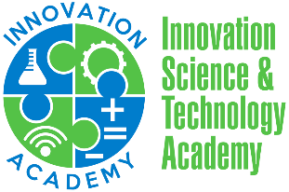

INNOVATION ACADEMY SCHOOL BOARD MEETING AGENDA 8/9/2020

Vision Statement
To develop globally conscious student innovators.

Mission Statement
Innovation Science & Technology Academy Charter School will develop talented student innovators using a cutting-edge curriculum with the collaborative support of staff, parents, and community. The collaborative culture and healthy school climate will foster personalized learning and ignite the power of imagination and creativity in our students, who will grow to be critical thinkers, problem solvers, and agents of change.

- Vision, Mission, & Norms

- Approval of Agenda

- Approval of Board Minutes
  - July 14, 2020

- Conflict of Interest

- NEO Observation

- Recruitment and Enrollment

- Procurement

- Fair and Open Hiring

- Ready to Open Checklist

- Open House

- Upcoming Agenda

- Sit-In Board Training

