Join our Patient Portal
Your healthcare is right at your fingertips.

- Schedule appointments
- Request prescription renewals
- Pay your bill

- View medical information
- Message our team
- Submit forms

Register for the Patient Portal
Fill out the form at https//:advancedmd.com/137591/account/logon

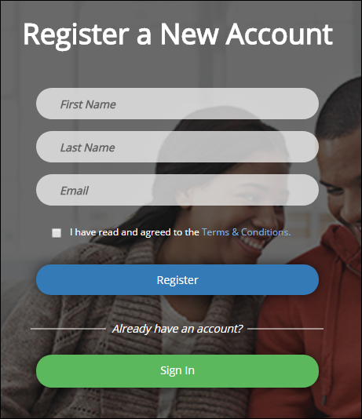
Note: Use the name and email our office has on file.
Click the link in the email you receive from our office.
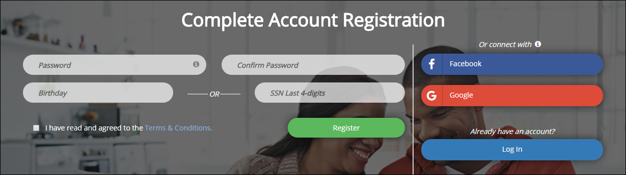
Register your account, or click the Facebook® or Google® button to link your social media account to the patient portal.
Note: You can also link your Facebook or Google account to the patient portal after registration by going to Profile | Update Profile Settings in the patient portal.

