EMPLOYMENT APPLICATION

INSTRUCTIONS: If you need help filling out this application form or for any phase of the employment process, please notify the person who gave you this form and every reasonable effort will be made to meet your needs in a reasonable amount of time.
Please read "Applicant Note” below.
Complete all pages pf this application.
Print clearly. Incomplete or illegible applications may not be accepted.
If more space is needed to complete any question, use comments section on the back.

APPLICANT NOTE: This application form is intended for use in evaluating your qualifications for employment with us, Aspire to Age, PBC. This is not an employment contract. Please answer all appropriate questions completely and accurately. False or misleading statements during the interview and on this form are grounds for terminating the application process or, if discovered after employment begins, terminating employment. All qualified applicants will receive consideration and will be treated throughout their employment without regard to race, color, religion, sex, national origin, age, disability, or any other protected class status under applicable law. Additional testing for the presence of illegal drugs in your body may be required prior to employment.

PERSONAL INFORMATION

Today’s Date: _________________________________

Positions(s) Applied For: _________________________________

Name: _______________________________ _________________________________
Last First

Current Address: ______________________________________________________________
Street, City, State, Zip Code

Home Phone: (______) ________________________

Cell Phone: (______) __________________________

Emergency Contact(s): 1) ________________________________________________
Name/ Relation

(______) _______________________________
Phone

2) ________________________________________________
Name/ Relation

(______) _______________________________
Phone

Are you able to perform the essential functions of the job for which you are applying with or without a reasonable accommodation? Yes / No

Do you have a reliable mode of transportation? Yes / No

Valid Driver’s License #: __________________________ State Issued:_____________

Exp. Date:__________________

Make & Model of Vehicle:____________________________________________

Year of vehicle:___________________

Auto In Co:__________________________

Policy #_____________________________ Exp Date:_____________________

Have you ever submitted an application here before? Yes / No

If yes, when? ___________________________________

How did you hear about our Home Instead Senior Care franchise?

___________________________________________

Why are you interested in employment with us?

____________________________________________________________________________________

____________________________________________________________________________________

Work Authorization
please attach with application

Passport copy

or

Drivers license and Social security number

or

Other

AVAILABILITY

Due to the nature of the business, no guarantee can be made as to the schedule or the number of hours worked.

What date are you available to begin work? ___________________________

How many hours are you willing to work per week? _______________________

How far will you be able to travel for work? ____________________________

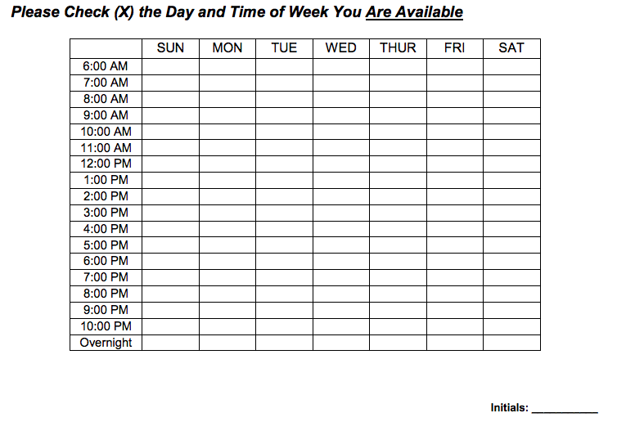
JOB RELATED SKILLS (Please attach another paper if you need more room)
Describe any training or life skills you have that apply to caring for a senior:

____________________________________________________________________________________

Describe any work history you have that would apply to caring for a senior:

____________________________________________________________________________________

What do you like (or think you would like) most about working with older adults?

____________________________________________________________________________________

What do you like (or think you would like) least about working with older adults?

____________________________________________________________________________________

What personal rewards do you get from working with seniors?

____________________________________________________________________________________

PREFERENCES
Individuals will be matched within a 30 mile zone.

Below are examples of services that you will be asked to provide:
 | Companionship |  | Housekeeping (dust/vacuum) |  | Errands/Shopping/Transportation*
 | Meal Preparation |  | Laundry/Ironing |  | Personal Care
 | Activities (games/crafts) |  | Medication Reminders |  | Dementia/Alzheimer’s Care
 | Daily Care |  | Home Management |  | Respite
 | Bathing |  | Toileting |  | Cleaning
*In order to be able to provide transportation or run errands, you will be required to have a valid driver’s license and current auto insurance. A motor vehicle record check will be conducted and proof of insurance will be required.

Indicate with an x if you will not be able to provide that service.

Please indicate Yes / No, if you are willing to do the list above (aside from the x).

Are you willing to provide service to a client with a pet? Yes / No
If yes, which ones: ______Cats ______Dogs

Are you willing to provide service to a client that smokes? Yes / No

EDUCATION

____________________________________________________________________________________

Do you have your Certified Nursing Assistant? Yes / No *may be requested for paper work
REFERENCES (Do not include relatives)
Please complete all three references. Your application will not be considered unless three references are provided. Since we will contact these references, please notify them in advance. If we are unable to reach all 3 references, you will be asked to provide additional references.

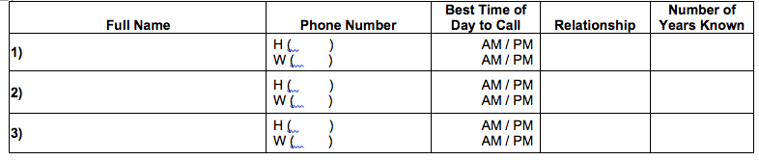

PLEASE SUBMIT OR ATTACH BACKGROUND CHECK

Completed? Yes / No

CERTIFICATION AND RELEASE: I certify that I have read and understand the applicant note on page one (1) of this form and that the answers given by me to the foregoing questions and the statements made by me are complete and true to the best of my knowledge and belief. I understand that any false information, omissions or misrepresentations of facts in this application may result in rejection of my application or discharge at any time during my employment. I authorize the company and/or its agents, including consumer-reporting bureaus, to verify any of this information including, but not limited to, criminal history and motor vehicle driving records. I authorize all persons, schools, companies and law enforcement authorities to release any information concerning my background and hereby release any said persons, schools, companies and law enforcement authorities from any liability for any damage whatsoever for issuing this information. I release this company from any liability which might result from making such investigations. I also understand that the use of illegal drugs is prohibited during employment. I am willing to submit to drug testing to detect the use of illegal drugs prior to and during employment. I understand that this application is not a contract of employment. My employment is contingent upon confirmation of credentials and successful completion of drug test or criminal background check. I also understand that if hired, regardless of any oral presentations to the contrary, the employment relationship between Interim Management Inc, and myself is terminable at-will, so that both the company and I remain free to choose to end out work relationship at any time for any or no reason. Any changes in this employment relationship must be made in writing. My signature below acknowledges that I have read, understand, and agree to the above disclosure. I also understand that due to the nature of the business, no amount of work can be guaranteed.

_____________________________________________________ _______________________

APPLICANT SIGNATURE DATE

