Infectious Diseases Associates, P.C.
729 Grove Avenue
Suite 4
Southampton, PA 18966

I Did Not Get that Memo

Packing

See brochure for packing instructions.
Plan a visit to the Dollar Store.
Buy ponchos and an umbrella. It is better to be prepared than not!
You can also buy a pop-up hamper (if you are staying in one hotel)
Five and Below sells water shoes.
Take comfortable walking shoes. People in other countries walk a lot more than we do.
Take a plastic trash bag to bring your dirty clothes home.
Don’t forget the charging cables for your phone, camera
Never pack your medications in your checked luggage!
Converters
Most countries use 220v rather than the 110v we use in the US. But the plugs are different in different countries. Make sure you have the correct converter otherwise, you will not be able to charge your phone, etc. Check with your hotel or travel company:
- Ask about specific electricity needs at your destination
- Ask if your hotel provides hair dryers
- According to the International Electrotechnical Commission (IEC), there are 14 different plugs (Type A through Type N) used around the world. See https://www.rei.com/learn/expert-advice/world-electricity-guide.html for World Plug Types.
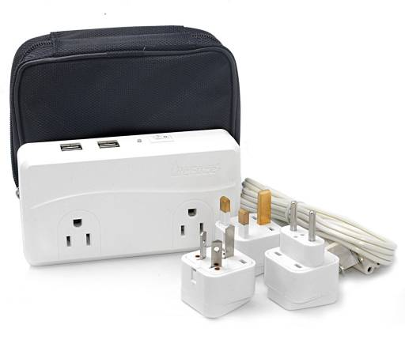
- There are also many converters for sale. You can purchase a converter which will only work in one country or one that will work in different countries. See : http://www.walkabouttravelgear.com/electb.htm

This is wall chart with the flags of various countries and a photo of the receptacle that country uses.
